**ST. ANNE’S**

**COLLEGE OF ENGINEERING AND TECHNOLOGY**

(Approved by AICTE, New Delhi. Affiliated to Anna University, Chennai)

(An ISO 9001: 2015 Certified Institution)

ANGUCHETTYPALAYAM, PANRUTI – 607 106.

**QUESTION BANK**

**PERIOD:** MARCH 2021 - JUNE 2021 **BATCH**: 2020 – 2024

**BRANCH:** ECE **YEAR/SEM:** II/IV

**SUB CODE/NAME:** EC8453 LINEAR INTEGRATED CIRCUITS

# UNIT I: BASICS OF OPERATIONAL AMPLIFIERS PART A

# What is a Voltage Reference? (D) Nov/Dec 2021

# A voltage reference is an electronic component or circuit that produces a constant [DC](https://whatis.techtarget.com/definition/DC-direct-current) (direct-current) output voltage regardless of variations in external conditions such as temperature, barometric pressure, humidity, [current](https://whatis.techtarget.com/definition/current) demand, or the passage of time.

# Why is the slew rate infinite an ideal op-amp? (D) Nov/Dec 2021

# For an ideal op-amp response time or time delay should be zero that is output voltage should respond instantaneously to any change in the input.

# Define slew rate. What causes slew rate? (D) Nov/Dec 2020 & Apr/May 2021 (May2014, 2015)

Slew rate is defined as the maximum rate of change of output voltage caused by a step input voltage and is usually specified is V/s.

Slew rate = dV0/dt V/s.

**Causes:**

Normally a capacitor used internally and externally in an op-amp to prevent oscillations. This Capacitor, Prevents the output voltage from responding immediately to fast changing input.

For 741 op-amp Imax = 15 A and internal compensation capacitor C= 30 pF

S.R = Imax/30pF = 15 A/30pF = 0.5 V/S.

# What are the assumptions made from ideal Op-amp characteristics? (or) List the ideal characteristics of an op-amp (or) List the characteristics of ideal Op-amp and draw its equivalent circuits? (D) (Nov 2014, May 2017, Nov 2018, Nov 2019, Nov 2020, May 2021)

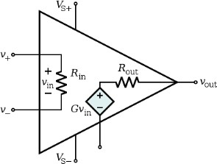The ideal characteristics of an op-amp are as follows:

Open loop voltage gain, AOL =

Infinite Input impedance, Ri = 

Zero Output impedance, RO =0

Infinite Bandwidth, BW =

Zero offset voltage, i.e. VO = 0 when V1 = V2 =0;

# Why is collector resistance replaced by a constant current source in differential amplifier? (ID) (Nov/Dec 2019)

# Large drop across Rc quiescent to maintain this high voltage need. The best idea to increase the open circuit voltage to use in differential amplifier.

# State the significance of current mirror circuit (D) (May2019)

The advantages of a current mirror are:

1.Low input impedance makes the input current insensitive to the output impedance of the input source 2.High output impedance makes the output current insensitive to the impedance of the output load 3.Inversion of sources to sinks or sinks to sources 4.Accurate gain 5.Shifts between different power rails.

# Mention the application of LF155. (ID) (May2019)

Precision High Speed Integrators, Fast D/A Converters, High Impedance Buffers Wideband, Low Noise, Low Drift Amplifiers, Logarithmic Amplifiers, Photocell Amplifiers, Sample And Hold Circuits.

# Define Differential Mode gain.(D)(Nov2018)

Differential-Mode voltage gain is the gain given to a voltage that appears between the two input terminals. It represents two different voltages on the inputs.

# Enumerate any two blocks associated with Op-Amp block schematic? (D) (May2018)

The blocks of an OP-AMP can be given as the differential amplifier, Voltage amplifier and the Output Amplifier.

# What are the two methods can be used to produce voltage sources? (D) (May 2018)

A voltage source is a circuit that produces an output voltage V0, which is independent of the load driven by the voltage source, or the output current supplied to the load. The two methods that can be used to produce a voltage source can be given as Voltage circuit using Impedance transformation and Common Collector type voltage source.

# Enumerate any four advantages of ICs over discrete component circuits. (D) (Nov2017)

Advantages of ICs over discrete components can be given as

Reduction in Size

Reliability is improved

Reduction of Power Consumption

Reduction of effects due to Noise.

# Find the maximum frequency for a sine wave output voltage of 12v peak with an OP-AMP whose slew rate is 0.5V/ µs. (ID) (Nov 2017)

Slew Rate = 2πfV

f = slew rate/(2πV) = 0.5*106/(2π*12) = 6.6KHz

# Find the maximum frequency for sine wave output voltage 10Vpp with an op-amp whose slew rate is 1V/µs. (May2016) (ID)

Vpp=10V (given); Slew Rate = 2πfmaxVm = 1V/µs =>fmax = (1 x 106)/ (2π x 5) = 31.83 kHz.

# Differentiate the Ideal and Practical characteristics of an op-amp. (D) (May2016)

|  |  |  |
| --- | --- | --- |
| **S.No** | **Ideal Characteristics** | **Practical Characteristics** |
| 1. | Open loop gain = ∞. | Open loop voltage gain is several thousands. |
| 2. | Input impedance = ∞. | Input impedance is greater than 1MΩ. |
| 3. | Output impedance = 0. | Output impedance is few hundred ohms. |
| 4. | Bandwidth = ∞. | Bandwidth is very small. |
| 5. | Zero Offset Vo = 0 when V1=V2=0. | Offset voltage is some non zero value. |

# A differential amplifier has a differential voltage gain of 2000 and a common mode gain of

**0.2. Determine the CMRR in dB. (ID)** **(May 2015)**

CMRR = 20 log |Ad/Ac|

Ad = 2000, Ac=0.2. (Given) CMRR = 2000 / 0.2 = 10000

CMRR in dB = 20 log |Ad/Ac| = 20 log 10000 = 20* 4 = 80dB.

1. **Define input bias current and input offset current of an operational amplifier.** (D) **(Nov 2015) Input Bias current:** The average of currents entering into the (-) input terminal & (+) input terminal of an op-amp is called input bias current. Its value is 500nA for741C.

**Input Offset Current:** The algebraic difference between the currents into the (-) input and (+)input is referred to as input offset current .It is 200Na maximum for 741C.

# Mention two advantages of active load over passive load in an operational amplifier. (D)(N’15)

The difference mode gain and CMRR is directly proportional to the RC in differential amplifier. The resistance value of RC is need to increase, to achieve high CMRR. But the use of large resistance value RC occupies large chip area and it needs large power supply. So the passive load RC is replaced by the current mirror as active load.

# An operational amplifier has a slew rate of 4V/µs. Determine the maximum frequency of operation to produce a distortion less output swing of 12V. (ID) (Nov2014)

**Slew rate (SR) =**2πfVp / 106 V/µs, Vp - Maximum amplitude of the output.

Given: SR = 4 V/µs, Vp= 12V

f = SR×106 / (2π×12) = 53.078kHz

1. **List the advantages of IC over discrete component circuit. (D) (Nov 2013)**

Low cost, Small size, High reliability, Improved performance.

# Define input offset current and input offset voltage. (D) (Nov2013)

**INPUT OFFSET CURRENT:** The algebraic difference between the currents into the (-) input and (+)input is referred to as input offset current .It is 200Na maximum for 741C.

**INPUT OFFSET VOLTAGE:** Ideally, for an Op-amp when no input is applied output voltage must be zero. However, some output voltage is present though input is not applied. Thus, offset voltage is the voltage that must be applied between the input terminals of an op-amp to nullify the output.

Since this voltage could be positive or negative its absolute value is listed on the data sheet. For 741C, maximum value is 6mV.

# Define CMRR AND PSRR. Mention their ideal values. (ID) (May2013)

**PSRR:** The change in an op-amp’s input offset voltage due to variations in supply voltage is called supply voltage rejection ratio. It is also termed as power supply rejection ratio or power supply sensitivity and gives the figure of merit  for the differential amplifier.

     = |Ad/Ac|

where Ad = Differential mode gain, Ac = common mode gain, CMRR is typically infinite

For 741C, SVRR=150V/V.

For 741C, SVRR=150V/V.

# What is the maximum undistorted amplitude, that a sine wave input of 10 kHz can produce at the output of an op-amp whose slew rate is 0.5 V/µs? (ID) (Nov2012)

Slew rate (SR)= 2πfVp / 106 V/µs, Vp- Maximum amplitude of the output Given: SR= 0.5 V/µs, f= 10kHz

Vp=SR×106 / (2π×10k)=1.99 V

# State the limitations of discrete circuits. (D) (May2013)

High cost, Large size, Low reliability, Reduced performance.

# What is the purpose of a current source in integrated circuits? (ID) (Nov2012)

By improving the CMRR of differential amplifier, its performance can be improved. To improve CMRR, common mode gain Ac must be reduced as much as possible. When this happens RE will be tending to infinity. But there are practical limitations in selecting the magnitude of an enormous value of resistance. Use of a constant current bias instead of RE is the practical solution for this problem. Without physically increasing the value of RE, the transistor operated at a constant current gives the effect of very high value of resistance. This is the importance of a current source in an IC.

# What is an op-amp? List its functions. (D)

The op-amp is a multi terminal device, which internally is quite complex. It is a direct-coupled high gain amplifier consisting of one or more differential amplifiers, followed by a level translator and an output stage. Function: Op-amp amplifies the difference between two input signals.

# List the essential terminals of an op-amp. (D)

Op-amp has five basic terminals, that is, two input terminals, one output terminal and two power supply terminals. Inverting input terminal : Pin 2,Non- inverting input terminal : Pin 3,Output terminal Pin 6 and Power supply terminals : Pin 4& 7

# Explain the virtual ground concept with a suitable example. (D)

We know that Vd = Va - Vb = 0; Node B is grounded. Therefore Vb = 0; But Vd = 0;Va = Vb; Node A is at virtual ground. ie since node B is at ground node A is also at ground imaginarily.

# Design a circuit using op-amp whose gain is–3. (ID)

# The op-amp inverting amplifier is shown.

Gain = Vo/Vi = -Rf/R1 = -3

*Let R*1  1*k*

Rf3*R*1 3*k*

# What are the factors that affect the stability of an op-amp? (D)

The factors that affect the stability of an op-amp are closed loop gain and phase shift.

# What are the various methods available for frequency compensation? (D)

There are two types of compensating techniques used for frequency compensation. They are namely External compensation and Internal compensation. External frequency has two methods for compensation namely Dominant pole compensation and Pole-zero compensation.

# Mention some applications of op-amp in open loop mode. (D)

Some of the applications of op-amp in open loop mode are as follows: Comparator, Zero crossing detector, Window detector, Time marker generator, Phase meter

# Why are FET op-amps better than BJT op-amps? Op-amps using FETs in the input stage offer some very significant advantages over bipolar op-amps, especially in areas as input impedance, input bias and offset currents and slewing rate as shown in table. (ID)

Op-amps using FETs in the input stage offer significant advantages over bipolar op-amps especially in areas as input impedance, input bias and offset currents and slew rate as shown in table:

|  |  |  |  |
| --- | --- | --- | --- |
| **Parameter** | **BJT** | **JFET** | **MOSFET** |
| Input resistance | K | 109 | 1012 |
| Input gate current | A | 1 nA | 1 pA |
| Input offset current | 20 nA | 2 pA | 0.5 pA |
| Slewing rate | 1 V/s | 3 V/s | 10 V/s |

# Explain thermal drift related to an op-amp. (D)

Bias current, offset current and offset voltage change with temperature. A circuit carefully nulled at 250C may not remain so when the temperature rises to 350C.This is called thermal drift. Often current drift is expressed in nA/0C and offset voltage drift in mV/0C.

1. **Why is current mirror circuit used in differential amplifier circuit?** (D)

A constant current source makes use of the fact that for a transistor in the active mode of operation. Thus in active region the collector current equal to output current which is approximately equal to Iref.

**Part B**

# [FIRST HALF]

**Current mirror and current sources**

1. With neat sketches, explain in detail the working of Widlar and Wilson current sources. **(13) (D) (Nov 2020)**
2. With a neat circuit diagram and with necessary equations, explain the concept of Widlar current source used in op-amp circuit.**(8) (D)**
3. Analyze the operations of basic BJT current mirror and thus explain its volt-ampere characteristics. (13) **(D)(Nov 2019)**

**BJT Differential amplifier with active loads**

1. Analyze the small signal model of BJT differential amplifier using h parameter and deduce the expression for differential and common mode gains for differential output. (13) **(D) (Nov 2019)**
2. Explain the working of BJT differential amplifier with active load.(12)**(D)(Nov 2013)**
3. Explain, with a circuit diagram, the working of BJT-emitter coupled differential amplifier. Also explain the concept of active load and sketch the relevant circuit diagram.(10)**(N/D’13,N/D’18) (D)**
4. Compare different configurations of differential amplifier.(8) **(May2013) (D)**
5. With the schematic diagram explain the effect of Re on CMRR in differential amplifier.(4)**(May 2016) (D)**
6. Discuss about the methods to improve CMRR. (12) **(May 2016) (D)**
7. For a dual input, balanced output differential amplifier, Rc=2.2kΩ, RE=4.7 kΩ, Rs1=Rs2=50Ω. The supply voltages are ± 10V. The hfe for the transistor is 50. Assume silicon transistors and hie= 1.4kΩ. Determine the operating point values, differential gain, common mode gain and CMRR. (8) **(ID)**
8. With simple schematic of differential amplifier, explain the function of operational amplifier. (7) **(D)**
9. Discuss about the principle of operation differential amplifier using BJT.**(May 2018) (D)**

**Basic information about op-amps – Ideal Operational Amplifier**

1. Write down the characteristics and their respective values of an ideal operational amplifier.(4)**(D)(Nov 2013)**
2. Explain about Ideal Op-Amp in detail with suitable diagrams.(8) **(May2018) (D)**
3. For the non-inverting op-amp shown in the figure below, find the output voltage Vo. (8) **(ID)**

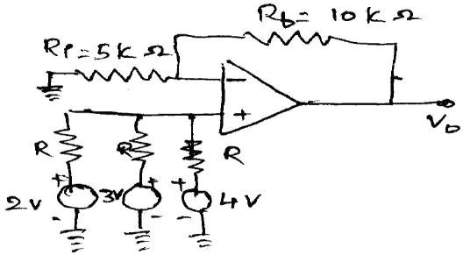

1. A non-inverting amplifier with the gain of 300 having an input offset voltage of ±3mV. Find the output voltage when the input is 0.01 sin t Volt. (4) **(May 2016) (ID)**

**[SECOND HALF]**

**General operational amplifier stages**

1. Draw and explain the block diagram of an Op-amp. Discuss the functions of each stage in detail. **(13) (N/D 2021)**
2. With a neat block diagram, explain the general stages of an OP-AMP IC.(6) **(N/D 17) (or)** List and explain the all basic building blocks of op-amp**(D)(13) (A/M 2019)**

**Internal circuit diagrams of IC 741**

1. With a neat diagram, explain the input side of the internal circuit diagram of IC 741. **(D)**(7) **(Nov2015)**

**DC and AC performance characteristics,**

1. List and explain the non-ideal DC characteristics of op-amp.(8)**(D)**
2. Explain AC characteristics of op-amp. **(D)** (**13**) **(Nov 2013, Nov 2014,Nov 2017,May 2019,Nov/Dec 2021)**
3. Draw the transfer characteristics of an operational amplifier and explain the linear and non-linear operation. **(D)**(8) **(Nov 2017, Nov2018)**
4. What is input and output voltage and current offset? How are they compensated? **(D)**(7) **(May‘17)**
5. Briefly explain the techniques used for frequency compensation. **(D)** (7)
6. Write a note on stability criteria and frequency compensation techniques applied in op- amp. **(D)**(12)
7. What is a need for frequency compensation in an op-amp? With the suitable illustration, explain the pole-zero frequency compensation technique.**(D)**(8)**(Nov2015)**

**Slew Rate**

1. Define Slew rate. In What way does it possess impact on performance of an op-amp circuit**.(D)(4) (Nov2018)**

**Open and closed loop configurations**

1. For the circuit shown in figure find out v0 as function of v1 and v2. **(13) ID (Nov 2020, April/May 2021)**



1. Draw the inverting and non-inverting amplifier circuits of an op-amp in closed-loop configuration. Obtain the expressions for the closed-loop gain in these circuits**(D)**(13)**(Nov 2017, Nov2018)**

**UNIT II: APPLICATIONS OF OPERATIONAL AMPLIFIERS**

**PART-A**

1. **Draw the circuit of Op-amp as a subtractor. (D) (Nov/Dec 2021)**

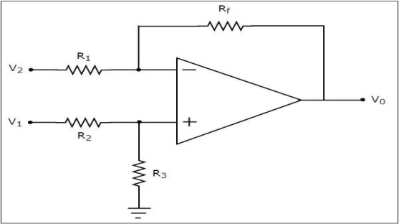

VO = V1-V2. The output voltage is equal to difference between two input signals.

# How does operational amplifier work as integrator? (D) (Nov/Dec 2021, Nov/Dec 2018)

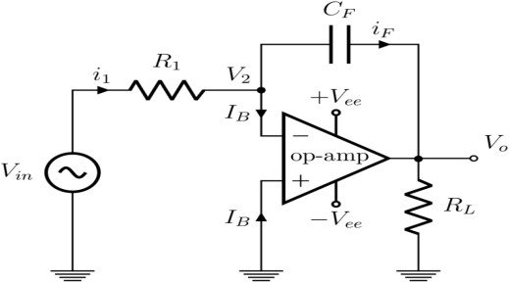

1. **What is a voltage follower? (D) (Nov 2020, April/May 2021, May2014)**

It is a circuit in which the output voltage follows the input voltage i.e. the output voltage is same as

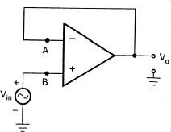that of the input voltage.

Gain = V0/Vi= 1 + (Rf/R1) = 1+0 = 1. Hence V0 = Vi

1. **What is the need of integrator?** **(D) (Nov 2020, April/May 2021)**

An integrator in measurement and control applications is an element whose output signal is the time integral of its input signal. ... It accumulates the input quantity over a defined time to produce a representative output. Integration is an important part of many engineering and scientific applications.

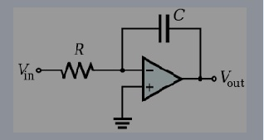

1. **What are the disadvantages of basic operational amplifier differentiator?(D) (Nov/Dec 2019)**

* At high frequency the ideal differentiator may become unstable and break into oscillation.
* The input impedance decreases with increase in frequency thereby making the circuit sensitive to high frequency noise.

1. **Audio filters are usually butterworth filter. Justify. (ID)(Nov/Dec 2019)**

* Filters in an electronic circuit which select a frequency. It passes the signal for specified range and attenuates the signal outside that specified range.

1. **Find the gain of Vo/Vi of the circuit.(ID)(May2019)**

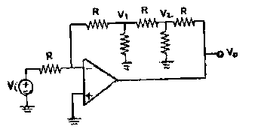

**Apply KCL at each node**

 (1)

 (2)

-----(3) By solving eqn 1,2 and 3 we get

# How does a zero crossing detector work? (D) (May2019)

It is used to compare two voltages simultaneously and changes the o/p according to the comparison. As shown in the waveform, for a reference voltage 0V, when the input sine wave passes through zero and goes in positive direction, the output voltage Vout is driven into negative saturation. Similarly, when the input voltage passes through zero and goes in the negative direction, the output voltage is driven to positive saturation

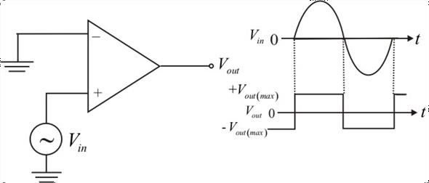

1. **Draw the circuit of clipper using op-amp. (D)(May2019)**

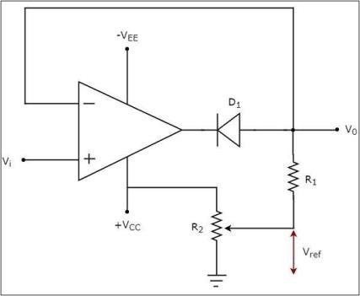

# What is the function of a phase shift circuit? (D)(May 2018)

Phase Shift circuits are combinations of resistive and capacitive elements which are used to give a change in the phase of the signal which adds a delay to the signal applied as input to the circuit.

# Write the other name for clipper circuit. (D)(May2018)

# The clipper circuit can also be called as the Level Limiting circuit. The signal gets limited to the desired voltage level fixed during the design of the circuit.

# What is a trans conductance amplifier and state any one application. (D) (Nov 2017)

Trans conductance amplifier is amplifier which takes the differential voltage input and gives the corresponding current output. The main application of the trans conductance amplifier is the voltage to current conversion (V to I).

1. 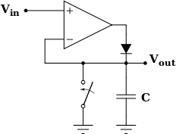**How will you realize peak detector using a precision rectifier (D)(Nov2017)**
2. **What is the need for converting first order filter to second order filter? (ID)(May2017)**

The need for converting first order filter to second order filter is second order filters has a roll-off rate of -40dB/decade and also it eliminates the need of inductors.

# How is the current characteristics of PN junction employed in log amplifier? (D) (May’17)

Log amplifier can be employed by using diode current equation given by IE =Is(eqVe/kT-1).Since the reverse saturation current Io for the diode changes with temperature, it is very difficult to set the Vref for the circuit. Thus the temperature affects the performance and accuracy of basic logarithmic amplifier circuit.

1. **What is a precision diode? How does it differ from the conventional amplifier?(D)(Nov.2012)**

A diode in the feedback loop of an op-amp behaves as a precision diode as its cut-in voltage gets divided by the open-loop gain of op-amp. This circuit is called the precision diode and is capable of rectifying input signals of the order of milli volt where the conventional diode cannot rectify below 0.7V**.**

# What is hysteresis and mention the purpose of hysteresis in a comparator? (D)(May2015)

If positive feedback is added to the comparator circuit, gain can be increased greatly. Consequently, thetransfercurveofcomparatorbecomesmoreclosetoidealcurve.Theoretically,if the loop gain AOL is adjusted to unity, then the gain with feedback, AVf becomes infinite. This results in an abrupt (zero rise time) transition between the extreme values of output voltage. In practical circuits, however, it may not be possible to maintain loop gain exactly equal to unity for a long time because of supply voltage and temperature variations. So a value greater than unity is chosen. This gives an output waveform virtually discontinuous at the comparison voltage. This circuit, however, now exhibits a phenomenon called hysteresis or backlash. Parameters which determine the hysteresis are upper threshold VUT and lower threshold VLT.

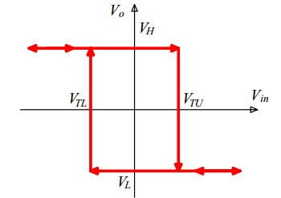

# Give an application of inverting amplifier.(D) (May2013)

Differentiator, Integrator, Rectifiers, Summer.

# How does precision rectifier differ from the conventional rectifier? (Nov 2012) (or) State the difference between conventional and precision rectifier? (Nov2014)

**(or) What is the difference between normal rectifier and precision rectifier? (May 2015)(ID)**

In conventional rectifiers, as long as the input exceeds the cut-in voltage of the diode, it does not conduct. Due to this, the output is distorted producing cross over distortion. For the input voltage between ± 0.7V, the output remains zero which is the main limitation of the conventional rectifier. The open loop gain of the opamp is very large. Hence for very small amount of the input, it produces large output which makes the diode conduct. Thus the diode conducts for very small input voltages of the order of milli volts. Hence, the precision rectifiers are very precise.

# Draw the circuit diagram of an op-amp differentiator circuit. (D) (Nov2012)

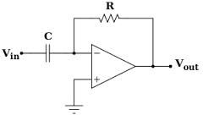

Vout= -RC (dVin/dt)

1. **Draw a non-inverting amplifier with voltage gain of 3.(ID) (Nov2013)**

Gain = V0/Vi= 1 + (Rf/R1) = 3 =>Rf/R1 = 2 =>Rf = 2 R1 let R1 = 1 KΩ =>Rf = 2 KΩ

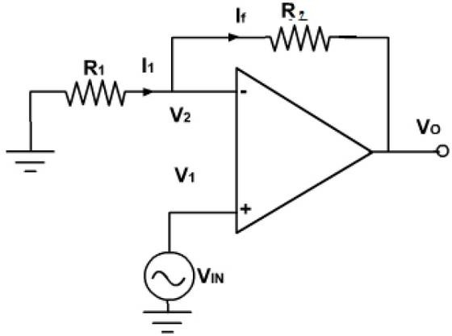

# Draw the circuit diagram of peak detector. (D)(May2014)

# Image result for peak detector using opamp

1. **Determine the output voltage for the circuit shown in fig when a) Vin = -2V (b) Vin = 3V. (ID) (Nov 2015)**

The condition for the determining the output of the comparator. If Vin >Vref ;Vout = +Vcc.

If Vin <Vref ;Vout = -Vcc

* 1. Vin = -2V (Given). As Vin<Vref, the output is+10V.
  2. Vin = 3V (Given). As Vin>Vref, the output is-10V.

# Plot the transfer characteristics of the circuit shown below, the opamp saturates at ±12V. (ID)(Nov 2015)

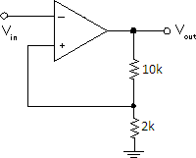 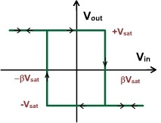

# What is a comparator? List the applications of comparator. (or) Draw the circuit diagram of the comparator. Mention its applications. (D) (May2016)

A comparator is a circuit, which compares a signal voltage applied at one input of an op-amp with a known reference voltage at the other input. It is basically an open loop op-amp with analog inputs and digital output (+ or – Vsat = Vcc ).

# Circuit Diagram:

**Application:** Zero crossing detector, Window detector, Time marker generator and, Phase meter.

# Calculate the output voltage for the circuit shown below. (ID) (May2016)

Vo = Rf (V1 – V2) / Ri = 2k (3-2)/2k = 1V.

1. **What are the limitations of basic differentiator? (D)**

At high frequencies, a differentiator may become unstable and break into oscillation. The input impedance (ie., 1/C1) decreases with increase in frequency, thereby making the circuit sensitive to high frequency noise.

# What is the limitation of basic integrator? (D)

At low frequencies, the feedback capacitor behaves as an open circuit and there is no negative feedback. The op-amp thus operates in open loop, resulting in an infinite gain. In practice, of course, output never becomes infinite, rather the output of the amplifier saturates at a voltage close to the op- amp positive or negative power supply depending on the polarity of the input dc signal.

1. **What is the use of differentiator and integrator circuits? (D)**

The op-amp differentiator and integrator are useful for signal wave shaping.

# On what does the damping co-efficient of a filter depend. (D)

Damping is determined by the amplifier’s gain. Bessel filter is a heavily damped filter (> 1.7). It is very stable, but rolls-off very early in the pass band.

Butterworth filters ( = 1.414) gives maximally flat pass band. A Chebyshev filters (< 1.4) provides faster initial roll-off rate but gives poorest transient response.

# What is an instrumentation amplifier? (D)

In a number of industrial and consumer applications, one is required to measure and control physical quantities. Some typical examples are measurement and control of temperature, humidity, light intensity, water flow etc. these physical quantities are usually measured with the help of transducers. The output of transducer has to be amplified so that it can drive the indicator or display system. This function is performed by an instrumentation amplifier.

# What are the features of an instrumentation amplifier? (D)

High gain accuracy, High CMRR, High gain stability with low temperature coefficient, Low dc offset Low output impedance. There are specially designed op-amps such as A 725 to meet the above stated requirements of a good instrumentation amplifier.

# What is the other name for voltage to current converter? What are the uses of V-to-I converters? (D)

The other name for voltage to current converter is the transconductance amplifier. The V-to-I converters are useful in low voltage dc and ac voltmeters, LED and Zener diode testers.

# What is the other name for current to voltage converter? What are the uses of I-to-V converters? (D)

The other name for current to voltage converter is the trans resistance amplifier. The I-to-V converters are used for testing photo devices. Photocell, photodiode and photovoltaic cell give an output current that is proportional to an incident radiant energy or light. The current through these devices can be converted to voltage by using a current to voltage converter and thereby the amount of light or radiant energy incident on the photo device can be measured.

# Discuss the disadvantages of passive filters.(D)

Passive filters work well for high frequencies, that is, radio frequencies. However, at audio frequencies, inductors become problematic, as the inductors become large, heavy, and expensive. For low frequency application, more number of turns of wire must be used which in turn adds to the series resistance degrading inductor’s performance, ie. Low quality factor results in high power dissipation.

1. **Why are active filters preferred?(D)**

Active filters are preferred over passive filters because they use op-amp as the active element, and resistors and capacitors as the passive elements. The active filters, by enclosing a capacitor in the feedback loop, avoid using inductors. In this way, inductor less RC active filters can be obtained. Also, as op-amp is used in non-inverting configuration, it offers high input impedance and low output impedance. This will improve the load drive capacity and load is isolated from the frequency- determining network. Because of the high input impedance of the op-amp, large value of resistors can be used, thereby reducing the value (size and cost) of the capacitors required in the design.

# What is a Sallen- Key filter?(D)

A second order filter consists of two RC pairs and has a roll-off rate of – 40 dB/decade. A general second order filter is known as Sallen –Key filter.

# What is Schmitt trigger?(D)

Schmitt trigger is a comparator with positive feedback. In this circuit, the input voltage triggers the output every time it exceeds certain voltage levels called upper threshold VUT and lower threshold VLT. It converts slowly varying waveforms into square wave.

# Draw the transfer characteristics of an ideal comparator and a practical comparator.(D)

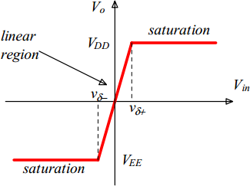 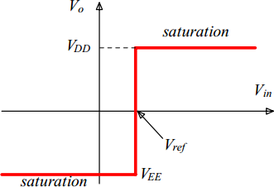

# Practical comparator Ideal comparator

**PART B**

**[First Half]**

**V-TO-I AND I-TO-V CONVERTERS**

1. Explain in detail about the V to I and I to V converters. D (13) **(Nov/Dec 2021**, **A/M 2015)**
2. With a neat circuit diagram explain the working of voltage to current converter. D (8) **(N/D 2015) (A/M 2018)**

**LOGARITHMIC AMPLIFIER, ANTILOGARITHMIC AMPLIFIER**

1. With neat diagram explain logarithmic amplifier and antilogarithmic amplifier. D (16) **(M/J 2014)**
2. Draw the circuit of temperature independent logarithmic amplifier and explain its operation. Also deduce the expression for output voltage. (**D) (8) (N/D 2019)**

**PRECISION RECTIFIER**

1. With a neat circuit diagram, explain the working of precision rectifier. D (8) (**N/D 2015**)
2. What is a precision rectifier? With circuit schematic explain the working principle of full wave rectifier? **ID** **(6)(A/M 2016)**
3. Explain the operation of precision full wave rectifier with neat sketch. **D (16)** **(N/D 2014)**
4. Explain the function of full wave rectifier using op-amp and diodes. **D (6) (N/D 2019)**
5. With neat diagram explain the application of op-amp as precision rectifier, clipper and clamper. **D (16)** **(M/J 2014)**

**INSTRUMENTATION AMPLIFIER**

1. With neat circuit diagram explain the working principle of instrumentation amplifier and derive its differential gain. **(13) (D) (Nov/Dec 2020, April/May 2021)**
2. Find Vo. Verify that if R3/R4=R1/R2, the circuit is an instrumentation amplifier with gain with A=1+R2/R1 **(ID)** (13) **(May2019)**
3. 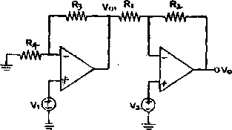Draw the circuit diagram of an instrumentation amplifier and explain its operation. list few application? D (12)(**A/M 2016)**
4. What is an instrumentation amplifier? Draw a system whose gain is controlled by a variable resistance. D

(7) (**N/D 2017)**

1. Explain the function of instrumentation amplifier and derive the expression for gain. (7) **(Nov/Dec 2019)**
2. Describe about the voltage follower circuit. D (7) **(A/M 2018)**
3. Write short notes on subtracted circuit D (6) (**A/M 2018**)

**[Second Half]**

**COMPARATORS**

1. Explain the circuit of a Non-inverting comparator. (6) **(Nov/Dec 2021)**

**SCHMITT TRIGGER**

1. (i) With neat diagram explain the operation of Schmitt trigger, precision rectifier (13) **(May 2019)**
2. Describe the circuit and working of a Square-wave generator. (7) (ID) **(Nov/Dec 2021)**

**INTEGRATOR, DIFFERENTIATOR**

1. Explain the application of operational amplifier as differentiator. (D) (8) (**N/D 2015)**
2. For performing differentiation in an operational amplifier, integrator is preferred to differentiator? Explain? ID (6) **(N/D 2017**)
3. With neat figures describe the circuit using Op Amps on the functioning of. (i) Integrator. and double integrator circuit ' First order High pass filter. ID (7+6) **Apr/May 2017**
4. (a) (i) Explain the circuit that performs the mathematical operation of differentiation. Draw its output waveform. (8)

(ii) Design an op-amp differentiator that will differentiate an input signal with fmax = 100Hz . **(7) (Nov 2021)**

1. (b) (i) Explain the circuit that provides an output voltage which is proportional to the time integral of the input. (8)

(ii) Consider a non-inverting integrator circuit. Show that V0= 1/ RC ∫V1 dt **(7) (Nov 2021)**

**LOW-PASS, HIGH-PASS AND BAND-PASS BUTTERWORTH FILTERS**

1. (i) Explain the issues and challenges in active filter design with example. (5)**(ID)**

(ii)The circuit given is inverting amplifier except the resister R3 is added. The circuit parameters are R1=5kΩ, R2=25kΩ, R3=12.5kΩ, RL=5kΩ (10) **(May2019)(ID)**

* + 1. Derive Vout expression
    2. Derive the expression forI3
    3. What happen to I3 if R3 is doubled?(R3=25kΩ)

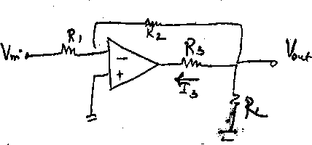

1. Analyze second order narrow band pass active filter circuit and obtain the expressions for transfer function, quality factor, bandwidth and centre frequency. **(D) (15) (Nov/Dec 2019)**
2. Design a second order high pull butter worth filter having cut off frequency of 5 KHz. **(ID)** (6)(A/M 2016)
3. Differentiate between low pass, high pass, band pass and band reject filter. sketch the frequency plot. D (8) **(N/D 2016)**
4. Design a second order high pull butter worth filter having cut off frequency of 1 KHz. ID (6)(N/D 2016)
5. Mention two advantages of active e filter over passive filter. also design a second order filter using operational amplifier for upper cut off frequency of 2 KHz. assume the value of capacitor to be 0.1µ F. ID (8) **(N/D 2015)**
6. Design a wide band pass filter having f L=400Hz, fH = 2 KHz and pass band gain of 4. Find the value of Q of the filter. ID **(8) (A/M 2015)**
7. Design a second order low pass Butter worth filter for a cut off frequency of 1 KHz. (10) D

**CLIPPER AND CLAMPER**

1. With neat diagram explain the application of op-amp as zero cross detector, precision rectifier, clipper, and clamper.(8) **(Nov 2013, May 2014, Nov 2014, Nov 2015, May 2017,May2019)**
2. Explain the function of positive clipper circuit with its input and output waveforms.(D) **(5) (N/D 2019)**
3. Write short notes on **: D (N/D 2016)**

i) Clipper and clamper circuits. (10) ii) Integrator. (6)

1. With neat figures describe the circuit using op amps on the functioning of **(D)**  (**A/M 2017)**
   1. zero crossing detector, clipper and clamper (7)
   2. Schmitt trigger (6)
2. Design a clipper circuit for a clipping level of +0.61V, given an input sine wave signal of 0.5V peak. Assume the gain of the amplifier is 12 and it has an input resistance of 1k -ohm connected. **(ID) (6)** **May/June 2016**
3. With neat figures describe, the circuit using Op Amps on the operation of (i) Zero cross detector, clipper and clamper circuits (ii) Schmitt Trigger. **D (7+6)** **Apr/May 2017**

**UNIT III: ANALOG MULTIPLIER AND PLL**

**PART- A**

# Mention two applications of Analog multiplier. (D) (Nov/Dec 2021) (Nov 2015)

Applications: Squarer, Square rooter, Frequency doubler etc.

1. **What is FSK modulation?(D) (Nov/Dec 2021)**

The Fsk stands for frequency shift keying. Binary data is transmitted by means of high frequency carrier which is shifted between two frequencies such as mark (Logic 1) and space (Logic 0) frequencies.

1. **List the features of 566 VCO. (D) (Nov/Dec 2020, April/May 2021)**

Wide supply voltage range 10V to 24V, High temperature stability, Linear modulation, characteristics, Frequency can be controlled by means of current, voltage, resistor or capacitor.

# Define lock range of a PLL. (D) (Nov/Dec 2021, Nov 2013)

The range of frequencies over which a PLL can maintain lock with the input signal is called lock- in-range.

1. **Define Capture range, Lock in range, Pull in time.(D) (Nov 2015, Nov 2017, Nov 2019) *Capture range:*** The range of frequencies over which the PLL can acquire lock with an input signal is called the capture range.

***Lock in range:*** The range of frequencies over which the PLL can maintain the lock with the incoming signal is called lock-in-range.

***Pull-in-time:*** The total time taken by the PLL to establish lock is called pull in time. This depends on the initial phase and frequency difference between the two signals as well as on the overall loop gain and loop filter characteristics.

# List the applications of multiplier ICs. (D) (Nov 2019)

* 1. Frequency Doubler
  2. Voltage Doubler
  3. Voltage squarer

# List the basic building block of a PLL. (D) (May 2019)

The basic building blocks of a PLL are phase detector, low pass filter, error amplifier and a voltage controlled oscillator.

# State any two terminologies associated with multiplier characteristics. (D) (May 2018)

The two terminologies associated with the multiplier characteristics can be given as Linearity and Accuracy.

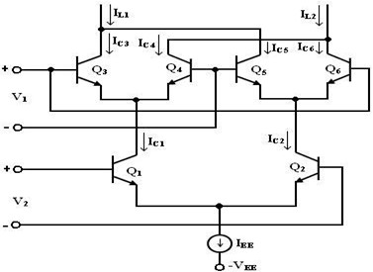

# What is Gilbert Multiplier Cell? (D) (May 2018, Nov 2018, May 2019)

The Gilbert multiplier cell is a modification of the emitter coupled cell and this allows four quadrant multiplication. Therefore, it forms the basis of most of the integrated circuit balanced Multipliers.

# List the applications of the PLL. (D) (May 2013, Nov 2018) (or) What are the applications of PLL for AM detection? (May 2015)

Some applications of PLL are: Frequency multiplier, divider, AM and FM demodulator, FSK demodulator.

# Mention the need of pre-distortion circuits in Gilbert analog multiplier and how is the configuration of Gilbert multiplier done with pre-distortion circuits. (ID) (Nov 2017)

Gilbert cell when used in analog multiplier needs a pre distortion circuit which is a diode circuit used to add a level of distortion equal to the opposite that is inherent in the differential pair.

# How is frequency stability obtained in PLL use of a VCO? (ID) (May 2017)

The frequency stability in PLL can be obtained by the voltage signal corresponding to the error voltage in the feedback loop.

# What is a four quadrant multiplier? (D) (May 2016)

A multiplier that accepts input of either polarity and preserves the correct polarity relationship at the output is called a four quadrant multiplier.

# What is the function of a phase detector in a PLL? (D) (Nov 2014)

A phase detector or phase comparator is a [frequency mixer,](https://en.wikipedia.org/wiki/Frequency_mixer) [analog multiplier](https://en.wikipedia.org/wiki/Analog_multiplier) or [logic](https://en.wikipedia.org/wiki/Digital_logic) circuit that generates a voltage signal which represents the difference in phase between two signal inputs. It is an essential element of the [phase-locked loop](https://en.wikipedia.org/wiki/Phase-locked_loop) (PLL).

# Define modulation index. (D) (Nov 2014)

The **modulation index** (or **modulation depth**) of a [modulation](https://en.wikipedia.org/wiki/Modulation) scheme describes by how much the modulated variable of the carrier signal varies around its unmodulated level. It is defined differently in each modulation scheme.

# What is the function of a phase detector in a PLL? (D) (Nov 2014)

A phase detector or phase comparator is a [frequency mixer,](https://en.wikipedia.org/wiki/Frequency_mixer) [analog multiplier](https://en.wikipedia.org/wiki/Analog_multiplier) or [logic](https://en.wikipedia.org/wiki/Digital_logic) circuit that generates a voltage signal which represents the difference in phase between two signal inputs. It is an essential element of the [phase-locked loop](https://en.wikipedia.org/wiki/Phase-locked_loop) (PLL).

# Explain the basic principle of PLL. (D) (May 2014)

PLL is a frequency selective circuit designed to synchronize with an incoming signal and 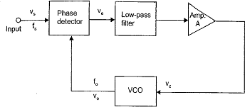maintain synchronization in spite of noise or variations in the incoming signal frequency.

# How voltage output of a PLL can be used as frequency discriminator? (or) Draw the circuit diagram of a PLL using as a FM Detector. (D) (May 2016)

When PLL is locked to an input frequency, the error voltage Vc(t) is proportional to (fs-fo).If the input frequency is varied as in the case of FM signal, Ve will also vary in order to maintain the lock. Then the volt output serves as a frequency discriminator, which converts the input frequency changes to voltage changes.

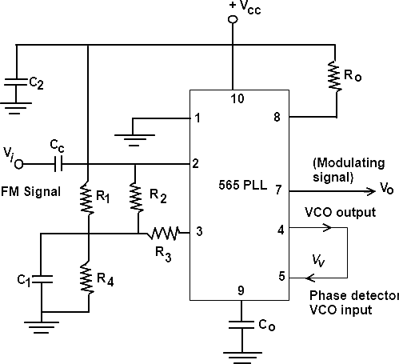

# A PLL frequency multiplier has an input frequency of “f” and a decade counter is included in the loop. What will be the frequency of the PLL output. (D) (May 2013)

Frequency of PLL output is f/10.

# What is the basic principle of VCO? (D) (Nov 2012)

Voltage controlled oscillator (VCO) is a free running multivibrator and operates at a set frequency fo. It is determined by an external timing capacitor and resistor .The frequency is shifted by applying a dc voltage Vc and is proportional to it. Hence, it is called voltage controlled oscillator. The applied input voltage determines the instantaneous oscillation frequency. Consequently, modulating signals applied to control input may cause frequency modulation (FM) or phase modulation (PM). A VCO may also be part of a phase-locked loop.

# How do you convert a basic multiplier to a squaring and square root circuit?

**(D) (May 2015, May 2017)**

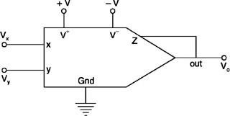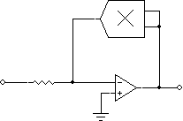

**Square root circuit Square circuit**

# What is meant by frequency synthesizing and its need? (D) (Nov 2013, May 2014)

A frequency synthesizer is [an electronic](http://en.wikipedia.org/wiki/Electronics) system for generating any of a range of [frequencies](http://en.wikipedia.org/wiki/Frequency) from a single fixed [time base](http://en.wikipedia.org/wiki/Quartz_clock) or [oscillator](http://en.wikipedia.org/wiki/Electronic_oscillator). They are found in many modern devices, including [radio](http://en.wikipedia.org/wiki/Radio) [receivers,](http://en.wikipedia.org/wiki/Receiver_(radio)) [mobile telephones,](http://en.wikipedia.org/wiki/Mobile_telephone) [radiotelephones,](http://en.wikipedia.org/wiki/Radiotelephone) [walkie-talkies,](http://en.wikipedia.org/wiki/Walkie-talkie) [CB radios,](http://en.wikipedia.org/wiki/CB_radio) satellite receivers , [GPS](http://en.wikipedia.org/wiki/GPS) systems, etc. A frequency synthesizer can combine [frequency multiplication,](http://en.wikipedia.org/wiki/Frequency_multiplier) [frequency division](http://en.wikipedia.org/wiki/Frequency_divider)

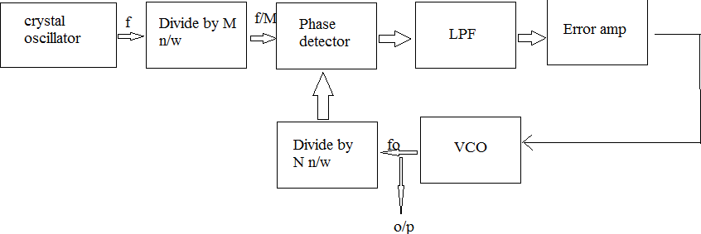

and [frequency mixing](http://en.wikipedia.org/wiki/Frequency_mixer) (the frequency mixing process generates sum and difference frequencies) operations to produce the desired output signal.

# What is a two quadrant multiplier? (D) (Nov 2012)

If one of the input signals is fixed, and the other may have either polarity, the multiplier is called a two quadrant multiplier and its output may have either polarity (and is “bipolar”).

# Explain the use of LPF in PLL. (D)

LPF is used in PLL to remove high frequency components and noise, Control the dynamic characters (capture range, lock range band width& transient response), provide a short time memory (given by the charge on the filter capacitor), provides a high noise immunity and locking stability.

# What is a multiplier? (D)

A multiplier produces an output Vo proportional to the product of two inputs Vx and Vy.

Vo = K Vx Vy Where K is the scale factor.

# Define voltage to frequency conversion factor. (D)

An important parameter for VCO is the voltage to frequency conversion factor. (Kv) is defined as Kv = (fo/Vc), Where Vc is the modulating voltage required to produce the frequency shift fo for a VCO.

# What is a phase detector? What are its types? (D)

Phase detector is a multiplier, which produces the sum (fs+fo) and difference (fs-fo) components at its output. There are two types of phase detector namely, Analog and digital.

# Draw the transfer characteristics of PLL. (D)

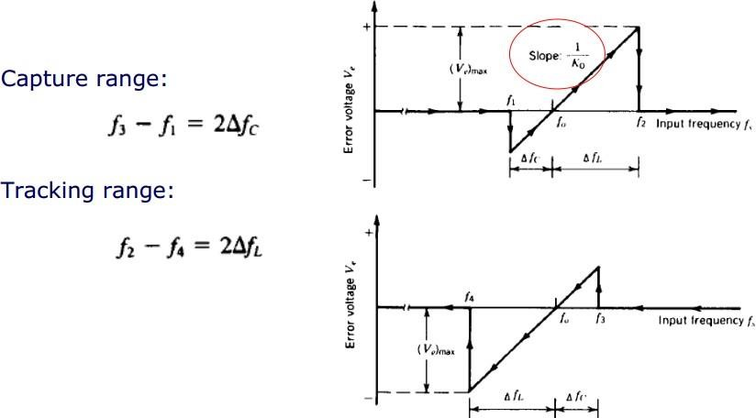

# List the advantages of a variable transconductance technique. (D)

Simple to integrate into monolithic chip, provides very good accuracy, very cheap hence economical, provides four quadrant operation, provides high speed of operation which is 2 to 3 times more than the logarithmic method, reduced error at least by 10, reduced error at least by 10 times and the bandwidth of 10 MHz and higher are available.

# List any 4 applications of VCO (D)

[Function generators](http://en.wikipedia.org/wiki/Function_generator), The production of [electronic music,](http://en.wikipedia.org/wiki/Electronic_music) to generate variable tones, [Phase-locked](http://en.wikipedia.org/wiki/Phase-locked_loop) [loops,](http://en.wikipedia.org/wiki/Phase-locked_loop) [Frequency synthesizers](http://en.wikipedia.org/wiki/Frequency_synthesizer) used in communication equipment.

# What are the applications of PLL as voltage output and as frequency output? (ID)

Voltage output is used in frequency discriminator applications where as the frequency o/p in used in signal conditioning, frequency synthesis or clock recovery applications.

# PART B

**First part**

# ANALOG MULITPLIER USING EMITTER COUPLED TRANSISTOR PAIR:

1. Describe the working principle of a analog multiplier using emitter coupled transistor pair.(D) (13) **(N/D’14)**
2. Explain the working of analog multiplier using emitter coupled transistor pair. Discuss the application of analog multiplier IC. (D) (13) **(May/ June 2014)**
3. Write notes on basic analog multiplication techniques(5) (D) **(N/D 2017)**
4. Discuss about Analog multiplier ICs. (D) (13) **April/May 2018**

# GILBERT MULTIPLIER CELL:

1. Describe about the Gilbert multiplier cell with relevant sketch **(7) (D) (Nov/Dec 2020, April/May 2021)**
2. Explain the function of gilbert multiplier cell and obtain the output differential current in terms of hyperbolic function. **(D) (7) (Nov 2019)**
3. With neat figures explain the emitter coupled circuit based design of i) Gilbert multiplier cell for four quadrant multiplication ii) the operation of VCO (13) (ID) **(A/M 2017)**

# VARIABLE TRNASCONDUCTANCE TECHNIQUE:

1. With neat simplified internal diagram, explain the working principle of operational trans conductance amplifier? (D) (10) (A**/M 2015)**
2. Explain the circuit of an Operational Transconductance amplifier and its Trasnsfer characteristics.(13) **(Nov/Dec 2021)**
3. Explain the working principle of four quadrant variable form trans conductance multiplier (D). (16) **(M/J 2016)**
4. Explain the operation of a variable trans conductance multiplier circuit .derive the expression for its output voltage. (D) (8) **(N/D 2017) ( N/D 2016**)

# Second part

**VCO:**

1. Explain the application of VCO for FM generation? (D) (6) (**A/M 2015)**
2. Derive the expression for the free running frequency of voltage controlled oscillator (5) (D) (**N/D 2017) (or)** Derive an expression for the frequency of the output waveform generated of VCO. Also define the Voltage to frequency conversion factor and obtain its equation. **(D) (13) (Nov 2017, 18)**

**PLL IC 565**

1. Mention the important building blocks of Phase Locked Loop (PLL) explain its working. (or) Explain the operation of the basic PLL with schematic diagram. (or) Discuss the principle of operation of NE 565 PLL circuit **(D) (13) (Nov/Dec 2020, May 2021, April/May 2018, M/J 2016)**
2. A PLL has free running frequency of 600 KHz and the bandwidth of the low pass filter is 4 KHz. Will the loop tend to acquire lock for an input signal of 520 KHz? Explain in this case, assume that the phase detector produces sum and difference frequency component (ID) **(May 2018)**
3. With a neat figures design a PLL with free running frequency of 500kHz an the Bandwidth of low pass filter is 50kHz. Will the loop acquire lock for an input signal of 600kHz. Justify your answer. Assume that phase detector need to produce sum and difference frequency components.**(ID) (May 2017)**
4. Define capture range, lock range. Explain the process of capturing the lock and also derive for capture range and lock range. **(D) (16) (A/M 2015)**
5. Show that the lock in range of PLL is directly proportional to the free running frequency of voltage controlled oscillator **(ID) (5) (Nov 2019)**
6. With block schematic explain the working principle of PLL IC NE 565 and explain the application of PLL IC for frequency multiplication. **(ID) (16) ( N/D 2016)**

# PLL/AM

1. Draw the circuit of a PLL used as AM detector and explain its operation. (6) (**May 2014, Nov 2015, Nov 2019, May 2019) (or)** With neat diagram describe the AM detection using PLL. (D) (8) **(Nov/Dec 2014)**

# PLL/FM

1. Explain with diagram how PLL can be used as (i) FM detector (8) (D) **(Nov 2013, June 2014, Nov 2015, 18) (or)** With neat diagram describe the FM detection using PLL. (D) (8) (**N/D 2014)**

**PLL/FSK**:

1. Draw the FSK modulator and demodulator circuits implemented using IC565 and explain its operation. **(13) (D) (Nov/Dec 2020, April/May 2021)**
2. Explain how IC 565 PLL can be used as a FSK demodulator.**(7) (May 2013, May 2014) (Nov 2017,May 2019) (or)** Explain the process of FSK demodulation using PLL .how is the stability of the frequency obtained in a PLL by the use of voltage controlled oscillator? (ID) (8) (**N/D 2017)**

# PLL/Frequency multiplier/Frequency synthesizer/Frequency division

1. Elucidate Frequency Multiplication and Translation using PLL (13) **(Nov/Dec 2021)**
2. How can PLL be modeled as a frequency multiplier (D) (6) (**M/J 2016)**
3. With neat diagram explain the design of i) frequency synthesizer ii)frequency division circuit using PLL IC 565 (D) (13) **(A/M 2017**)
4. Frequency synthesizer (Explain principle, characteristics and working) (D) (8) **(May 2013, May 2016, May2017, May2019, Nov 2018)**
5. Frequency division circuit using PLL IC 565 (D) **(May 2017, May 2019)**

**UNIT IV ANALOG TO DIGITAL AND DIGITAL TO ANALOG CONVERTERS**

# PART A (2 Marks)

# What output voltage would be produced by a D/A converter whose output range is 0 to 10V and whose input binary number is 10111100 for a 8 bit DAC? (ID) (Nov/Dec 2021)

Resolution= VFS/2n-1 = (10-0)v/28 -1 = 0.0392

VO = Resolution x (Decimal equivalent of input binary) = 0.0392x188= 7.37 V

Output voltage= [(Output range)/2n - 1] x (Decimal equivalent of input binary)

= [(10-0)/28-1] x (188) = 7.37V

1. **Give the resolution of an 8-bit ADC of by input range? (ID) (Nov 2021)**

Resolution= VFS/2n-1; Consider VFS = 0 to 1 V

Resolution = 1/28-1=1/255=0.00392

%Resolution = 0.00392x100=0.392

1. **What is Integrating type Converter?** **(ID) (Nov/Dec 2020, April/May 2021)**

If an ADC performs the analog to digital conversion by an indirect method, then it is called an Indirect type ADC. In general, first it converts the analog input into a linear function of time (or frequency) and then it will produce the digital (binary) output.

EX: Dual Slope Integrating ADC

# List out the main advantages and disadvantages of R/2R Ladder type DAC. (D)

**Advantages**

* Easier to build accurately as only two precision metal film resistors are required
* Number of bits can be expanded by adding more sections of same R/2R values.
* In inverted R/2R ladder DAC, node voltages remain constant with changing input binary words. This avoids any slowdown effects by stray capacitances

# Disadvantages

# It needs various types and ranges of resistors which is difficult to maintain in the circuit and also it the presence of so many resistors will create some problems in the circuit.

# it has slower conversion rate.

1. **What are the drawbacks of binary weighted resistor D/A converter?** (D) **(Nov 2012, N/D’ 2019)** Wide range of resistor values are required, It is impracticable to fabricate large values of resistance in IC and voltage drop across such large resistors due to this bias current also affects accuracy.
2. **Define settling time. (D) (May 2019)**

Settling time represents the time it takes for the output to settle within a specified band ±(1/2) LSB of its final value, after the change in digital input .It should be as small as possible.

# Estimate the conversion time of a 10 bit successive approximation analog to digital converter if the input clock is 5 MHz. (ID) (Nov/Dec 2019)

Given: n=10 and fclk = 5 MHz

conversion time : tcon = n x (1/fclk)

tcon = 10 x (1/(5 x 106)) = 0.02 µs.

# What is the largest value of output voltage from an 8 bit DAC that produces 1.0 V for a digital input 00110010? (ID) (May2019)

(00110010)2 = 50

1.0V = K× 50

Therefore, K = 20 mV

# Write the basic principle of sample and hold circuits. (D) (Nov 2013, May 2014,Nov 2018)

The sample and hold circuit samples the value of the input signal in response to a sampling command and hold it at the output until arrival of the next command. It samples an analog input voltage in a very short period and holds the sampled voltage level for an extended period.

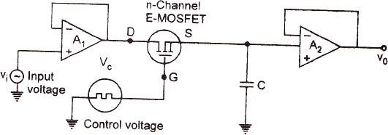

1. **Write the names of the switches used in MOS Transistors.** (ID) **(May 2018)**

The switches used in MOS transistors are NMOS switches and PMOS switches.

# How is the classification of A/D converters carried out based on their operational features?

(ID) **(Nov 2017)**

The types of A/D Converters are Flash type, Successive Approximation Type, Sigma Delta type etc.

# Find the number of resistors required for an 8 bit weighted resistor D/A converter. Consider the smallest resistance is R and obtain those resistance values. (ID) (Nov 2017)

The total numbers of resistors needed are 8. The resistance values needed are 2R,4R,8R,16R,32R,64 R,128R,256R.

# Differentiate between direct type and integrating type in ADC converters. (D) (Nov 2018)

|  |  |
| --- | --- |
| **Direct type ADC** | **Integrating type ADC** |
| 1. If the ADC performs the analog to digital conversion directly by utilizing the internally generated equivalent digital (binary) code for comparing with the analog input, then it is called as **Direct type ADC**. 2. Counter type ADC   Successive Approximation ADC, Flash type ADC | 1. If an ADC performs the analog to digital conversion by an indirect method, then it is called an **Indirect type ADC**. In general, first it converts the analog input into a linear function of time (or frequency) and then it will produce the digital (binary) output. 2. Dual slope ADC |

# An 8 bit A/D converter accepts an input voltage signal of range 0 to 12V. What is the digital output for an input voltage of 6V? (ID) (May 2017)

M = 2n – 1

a / Vmax = d / M

6 / 12 = d / (256 - 1) =1111111.1

# Why are Scottky diodes used in sample and hold circuits? (ID) (May 2017)

Scottky diodes used in sample and hold circuits for high speed switching operation.

# Define Sampling. (ID) (May 2018)

Sampling is the first step of digital to analog conversion. The continuous input signal is converted into discrete signal by taking the voltage value at various points in time.

# Give the advantages of R/2R ladder DAC. (or) Mention two advantages of R/2R ladder DAC when compared to weighted resistor type DAC. (ID) (Nov 2015)

Easier to build accurately as only two precision metal film resistors are required whereas in weighted resistor type DAC, a wide range of resistor values are required, it is impracticable to fabricate large values of resistance in IC. No. of bits can be expanded by adding more sections of same R/2R values. In inverted R/2R ladder DAC node voltages remain constant with changing input binary words. This avoids any slow down effects by stray capacitances.

# Draw the binary ladder network of DAC. If the value of the smallest resistance is 10k, what is the value of the other resistance? (ID) (May 2016)

R = 10k; VR = 10V; n=3

For value of 1 LSB = 0.5V (Rf x VR) / (R x 2n) = 0.5

# For a n-bit flash type A/D converter, how many comparators are required? State the

# disadvantage of that type of converter. (or) Determine the number of comparators and resistors required for 8-bit flash type ADC. (ID) (May 2013, Nov 2015)

n- bit flash type A/D convertor requires 2n-1 comparators.

**Disadvantages**: A Flash converter requires a huge number of comparators compared to other ADCs, especially as the precision increases. A Flash converter requires 2n-1 comparators for an *n*- bit conversion. The size, power consumption, and cost of all those comparators make Flash converters generally impractical for precisions much greater than 8 bits (255 comparators).

# Give the applications of the S/H circuit (or) Give the applications of sample and hold circuit. (D) (Nov 2014)

Digital interfacing, A/D converter circuits, Pulse modulation systems, In analog DEMUX.

# A 12 bit D/A convertor has resolution of 20 mV/LSB. Find the full scale output voltage.

(ID) **(May 2016)**

Resolution = VFS / (2n – 1) =

VFS = 20x10-3 x (212 – 1) = 81.9 V

# What is oversampling? (ID) (May 2015)

[In signal processing,](https://en.wikipedia.org/wiki/Signal_processing) oversampling is the process of [sampling](https://en.wikipedia.org/wiki/Sampling_(signal_processing)) a signal with a [sampling](https://en.wikipedia.org/wiki/Sampling_frequency) [frequency](https://en.wikipedia.org/wiki/Sampling_frequency) significantly higher than the [Nyquist rate](https://en.wikipedia.org/wiki/Nyquist_rate). Theoretically, a bandwidth-limited signal can be perfectly reconstructed if sampled above the Nyquist rate, which is twice the highest frequency in the signal. Oversampling improves [resolution,](https://en.wikipedia.org/wiki/Resolution_(audio)) reduces [noise](https://en.wikipedia.org/wiki/Noise) and helps avoid [aliasing](https://en.wikipedia.org/wiki/Aliasing) and [phase distortion](https://en.wikipedia.org/wiki/Phase_distortion) by relaxing [anti-aliasing filter](https://en.wikipedia.org/wiki/Anti-aliasing_filter) performance requirements.

# Define resolution of a DAC. (D) (Nov 2014)

Resolution is the number of different analog output values that can be provided by a DAC. For an n-bit DAC, Resolution=2n. Resolution is also defined as the ratio of a change in output voltage resulting from a change of 1LSB at the digital inputs. For an n-bit DAC, Resolution=VOFS / (2n- 1); VOFS - Full scale output voltage.

# What output voltage would be produced by a D/A converter whose output range is 0 to 10V and whose input binary number is 0110 for a 4 bit DAC? (ID) (Nov 2012)

Output voltage= [(Output range)/2n] x (Decimal equivalent of input binary) = (10-0)/24 x (6) = 3.75V

# Mention any two specifications of a D/A converter. (D) (May 2013)

* 1. Resolution, b. Linearity, c. Accuracy, d. Settling time, e. Monotonicity and f. Stability.

# Give any two advantages of SA type ADC. (D) (May 2014)

# It uses very efficient code searching strategy called binary search.

# High speed of conversion. Time for one analog to digital conversion is Tc=T(n+1) where T is the clock period and n is the number of bits.

# Mention any two specifications of a D/A converter. (D) (May 2013)

# Resolution, b. Linearity, c. Accuracy, d. Settling time, e. Monotonicity and f. Stability.

# Give any two advantages of SA type ADC. (D) (May 2014)

# It uses very efficient code searching strategy called binary search.

# High speed of conversion. Time for one analog to digital conversion is Tc=T(n+1) where T is the clock period and n is the number of bits.

# What is the drawback of dual slope ADC? (D) (Nov 2012)

# Slow speed, accuracy is dependent on the use of precision external components, high cost.

# Define accuracy of a DAC. (D)

# Accuracy is a comparison of actual output voltage with expected output. It is expressed in percentage. Ideally the accuracy of the DAC should be, at worst + ½ LSB.

# Accuracy = VOFS / ((2n-1)* 2)

# Define conversion time of a DAC. Also define settling time of a DAC. (D)

# Conversion time is the time required for conversion of analog signal into its digital equivalent. Settling time is time required for the output of the DAC to settle to within + ½ LSB of the final value for a given digital input

# i.e. 0 to full scale. Settling time ranges from 100ns to 10µs.

# Write the principle involved in successive approximation ADC. (D)

# In this technique, the basic idea is to adjust the DACs input code such that its output is within +

# ½ LSB of the analog input Vi to be A/D converted. The successive approximation method uses very efficient code searching strategy called binary search. It completes searching process for n bit conversion in just n clock periods.

# Which type of ADC is the fastest and why? (D)

# Flash A/D converter also known as the simultaneous or parallel comparator is the fastest of all ADCs because the fast conversion speed is accomplished by providing 2n-1 comparators and simultaneously comparing the input signals with unique reference levels spaced one LSB apart.

# What are the advantages of Adaptive delta modulation over delta modulation? (D)

# The signal to noise ratio is better than ordinary delta modulation because of the reduction in slope overload distortion and granular noise , Because of the variable step size the dynamic range of ADM is wide , Utilization of bandwidth is better than delta modulation.

# What are the advantages and disadvantages of Flash type ADC? (D)

# Flash type ADC are the fastest type of convertors present in the ADC since they use comparison technique it is also having speed and the disadvantage is that if the comparison is too large it takes more duration to convert.

# What are the different classifications of ADC? (D)

# SAR Type, Counter Type, Single slope type and dual slope type are the various classifications of ADC.

# State the principle of single slope A/D converter. (D) (Nov 2013)

# Initially the reset signal is applied to ramp generator.

# Then input voltage is applied to the comparator. This produces a high output. Hence output of AND gate is high. This high output starts the binary counter and the ramp generator.

# As long as the output of AND gate is high the counter keeps counting. When the output of ramp generator is lower than analog input, the output of AND is low and the counter stops counter. The value displayed by the counter is proportional to analog input.

# 

# PART B

**First part**

**ANALOG AND DIGITAL CONVERSION**:

1. With a neat block diagram, Explain the working of successive approximation type ADC. Also determine the conversion time of 8 bit and 16 bit successive approximation type ADC if its clock frequency is 50Hz. **(D)** (Nov 2015, Nov 2018)
2. What is sample and hold circuit? Briefly explain its construction and application.(8) D **(A/M 2010)**
3. State the significance of using high speed sample and hold circuits. Explain its working principle? (D) (12) (A/M 2016)

**D/A CONVERTER:**

1. Explain weighted resistor type and R-2R ladder type DAC. **(D) (13) (Nov/Dec 2021, May/June 2014)**
2. Describe in detail about binary weighted resistor type digital to analog converter with necessary circuit diagram. **(13) (Nov/Dec 2020, April/May 2021)**
3. For a 4 bit R-2R ladder D/A converter assume that the full scale voltage is 16V. Calculate the step change in output voltage on input varying from 0111 to 1111. **(D)** (**Nov 2018)**
4. Explain the following DAC with suitable circuit diagram:
   1. Binary weighted resistor DAC (8)
   2. Inverted R-2R Ladder DAC (8) **(D)** (**Nov 2012, Nov 2013, Nov 2014, May 2015, Nov 2017)**
5. Enumerate the specifications of D/A Converter. **(D) (May 2018,May 2019)**
6. Explain voltage mode and current mode operations of R-2R ladder type DAC. Compare performance of various DACs (8) **(D) (May 2014, May 2016,May 2019,Nov 2018)**
7. Explain in detail on the operational features of 4 – bit weighted resistor type D/A converter **(D) (Nov/Dec 2017)**
8. Differentiate between current mode and voltage mode R-2R ladder D/A converters? **(D) (6) (N/D 2017)**
9. Enumerate the specifications of D/A converters. **(D) (13) A/M 2018)**

# SECOND PART

**A/D CONVERTER:**

1. Explain the following types of ADCs: (i) Flash ADC (ii) Counter type ADC **(13) (Nov/Dec 2021)**
2. Draw the dual slope ADC and explain its working. **(13) (Nov/Dec 2020, April/May 2021)**
3. A dual slope ADC uses a 16-bit counter and a 4MHZ clock rate. The maximum input voltage is

+10V. The maximum integrator output voltage should be -8V when the counter has recycled through 2n counts. The capacitor used in the integrator is 0.1 µF. Find the value of resistor R of the integrator.(8) **(D) (Nov 2017)**

1. Draw the circuit of flash type ADC and explain. (or) With a neat block diagram, explain the working 2-bit flash type ADC. **(D) (Nov 2014, Nov 2015,Nov 2018)**
2. Explain the oversampling A/D converter with functional block diagram. **(D)** (**Nov 2018**)(8)
3. With neat sketch explain the working of a flash type ADC. (D) (16) **(N/D 2014)**
4. Explain the working of success approximation ADC. (D) (8) **(A/M 2010, A/M 2017)**
5. With a neat block diagram, explain the operation of successive approximation type A/D converter in detail?(5) (D) **(N/D 2017)(M/J 2016)**
6. Write note on Analog switches. (D) (6)**(A/M 2017)**
7. Explain Flash type, single slope type and dual slope type ADC. **(D)** (16) **(M/ J 2014)(N/D 2016)**
8. What is meant by resolution, offset error in ADC **(D)** (6) **(A/M 2017)**
9. Give a table of comparison of Flash, Dual slope and successive-approximation ADCs in terms of parameters like speed, accuracy, resolution, input-hold-time. **(D)** (6) **(May/June 2012)**
10. An 8 -bit A/D converter accepts an input voltage signal of range 0 to 9V.What is the minimum value of the input voltage required for generating a change of 1 least significant bit? Specify the digital output for an input voltage of 4 V. What input voltage will generate all is at the A/D converter output? **(ID)** (8)(**N/D 2017)**
11. With a neat block diagram, explain the operation of successive approximation type A/D converter in detail.

**(D)** (8) (**N/D 2017)**

1. Describe in detail about the single slope type ADC with neat sketch (13) D (**A/M 2018)**
2. With a neat block diagram explain the stages for developing the signal analysis circuits required for an instrumentation module of say a vibration sensor data using instrumentation amplifier, wave shaper, comparator and ADC using OPAMP and required components.(ID) (13) **April/May 2017**

# A/D CONVERTER USING VOLTAGE TO TIME CONVERSION:

1. Assume the following values for the ADC clock frequency = 1 MHz; DAC has F.S. output

= 10.23 V and a 10-bit input. Determine the following values**. (ID) (8) (May 2019)**

1. The digital equivalent obtained for VA = 3.728 V.
2. The conversion time.
3. The resolution of this converter

(ii)A 10-bit DAC has a step size of 10 mV. Determine the full-scale output voltage and the percentage resolution.

1. With functional block diagram explain A/D converter using voltage to time converter with input and output waveform. **(ID)** (16) **(N/D 2016)**
2. Describe the operation of dual slope and successive approximation type ADC. What are the

advantages of dual slope ADC? **(ID) () (Nov 2012, May 2014, May 2015, Nov 2013, May 2016, May 2017,Nov 2017)**

1. With a neat block diagram, Explain the working of successive approximation type ADC. Also determine the conversion time of 8 bit and 16 bit successive approximation type ADC if its clock frequency is 50Hz. **(D) (13) (Nov 2015,Nov 2018)**
2. (i) How are A/ D converter categorized? **(D)** (6) **(May 2017)**

(ii) What is meant by resolution, offset error in ADC? (7) **(D) (May 2017)**

1. Describe in detail about the single slope type ADC with neat sketch. **(D) (8) (May 2018)**

# UNIT V- WAVEFORM GENERATORS AND SPECIAL FUNCTION ICs

1. **Draw the functional diagram of 555 timer? (D) (Nov/Dec 2021)**

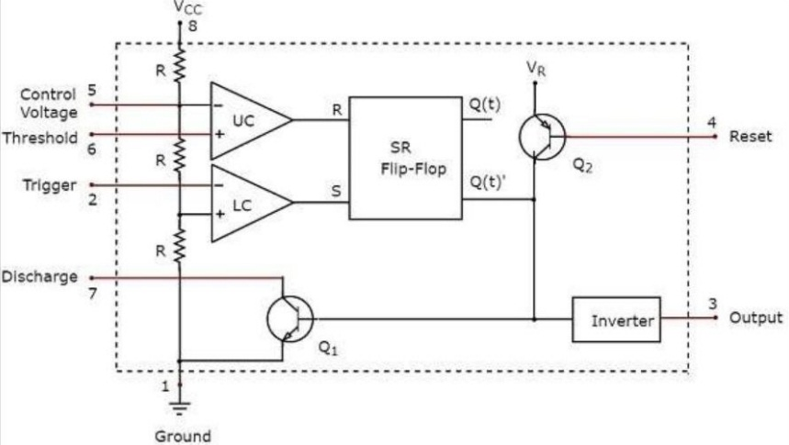

1. **State the principle used in Voltage to Frequency conversion? (D) (Nov/Dec 2021)**

A voltage-to-frequency converter (VFC) is an oscillator whose frequency is linearly proportional to a control voltage. The VFC/counter ADC is monotonic and free of missing codes, integrates noise, and can consume very little power. It is also very useful for telemetry applications.

1. **What is the necessity of having input and output capacitors in three terminal IC regulators? (May 2021)**

The only discrete external part optionally demanded are a capacitor on the input and the output leads of the IC. These capacitors are necessary to enhance the level of output regulation of the device, and to improve the transient response

1. **Mention the advantages of opto-couplers?**

The main advantages of opto-coupler are:

* one-way transmission of signal,
* complete electrical isolation between input and output,
* no influence of output signal on the input,
* strong anti-interference ability,
* stable operation
* long service life and high transmission efficiency.

# List the types of multivibrators. (May 2014, May 2019)

* 1. Monostable multivibrator using 555 timer, b) Astable multivibrator using 555 timer.

1. **Draw the functional block diagram of 723 Regulator. (May 2015,Nov 2018)**

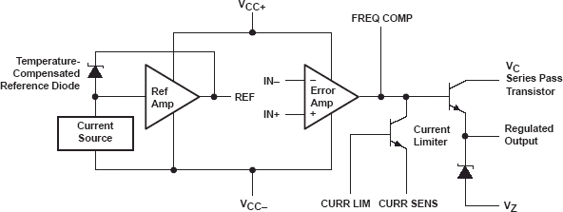

# What is an opto coupler? (May 2014, May 2019)

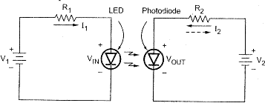

The combined package of LED and photodiode is called opto coupler. When V1 is changed the current I1 in the input circuit changes and thus the light emitted by LED also change. This light falls on photo diode and hence produces corresponding current in the output circuit. Thus the current I2 in the output circuit also changes. The output voltage is the potential difference between V2 and drop across R2. Thus, the change in input voltage produces a corresponding change in output voltage.

# List the various application of Multivibrator (Nov 2018).

**Applications astable multivibrator**

* 1. The astable or free running multivibrator is used as a square wave frequency generator
  2. As a timing oscillator or clock of a computer system.

**Applications of mono stable multivibrator**

* 1. The monostable multivibrator is used as delay and timing circuits.
  2. It is often used to trigger another pulse generator.

**Bistable multivibrator applications**

* 1. The bistable multivibrator or Flip Flop is of great importance in digital operation in computers, digital communications.
  2. It is also used for reversing to the supply to a given circuit or change supply to two circuit at regular intervals.

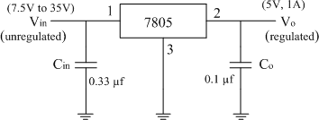

# Name some LC Oscillator circuits.(May 2018)

Some of the LC oscillator circuits can be given as Hartley Oscillators, Colpitt’s Oscillator etc.

# Define Line regulation.(May 2018)

Line regulation is the ability of the power supply to maintain its specified output voltage over changes in the input line voltage.

# Define current transfer ratio of an opto-coupler (Nov 2017)

**Current Transfer Ratio:**

It is defined as the ratio of output collector current (Ic) to the input forward current (If) CTR = Ic/If * 100%. Its value depends on the devices used as source & detector.

# Draw a fixed voltage regulator circuit and state its operations (Nov 2017)

Given is a fixed 5V regulator circuit using IC 7805. For variable input output is 5V.

# Differentiate between linear and switching regulator (May 2017)

|  |  |
| --- | --- |
| **Linear regulator** | **Switching regulator** |
| Here the pass transistor is operated  its linear region to provide a controlled controlled voltage drop across with a steady dc current flow . | Here the pass transistor is used as controlled switch and is operated at either cutoff or saturated state. Hence the power transmitted across the pass device is discrete pulses rather than a steady  current flow |

1. **List and explain the characteristics of a three terminal voltage regulator IC (May 2017).**

1. Output Voltage Vo: The regulated output voltage is fixed at a value as specified by the manufacturer. There are a number of models available for different output voltages, for example, 78XX series has output.

2.|Vin| >= |V0| + 2V,

1. Io max,
2. Thermal shut down

# What is an isolation amplifier? Mention its applications. (May 2016)

Isolation amplifiers are a form of differential amplifier that allow measurement of small signals in the presence of a high common mode voltage by providing electrical isolation and an electrical safety barrier. They protect data acquisition components from common mode voltages, which are potential differences between instrument ground and signal ground. Its applications are Industrial process control, transducer sensing, motor and SCR control, Ground loop elimination, biomedical measurements, test equipments and data acquisition.

# What is the purpose of connecting a capacitor at the input and output side of an IC voltage regulator. (Nov 2015)

Input capacitance is used to cancel the inductive effects due to long distribution leads. Output capacitance is used to improve the transient response.

# Mention two applications of Frequency to voltage converter. (Nov 2015)

Frequency-to-voltage converters are used in a variety of industries and applications. For example, vehicle-monitoring applications use frequency-to-voltage converters to evaluate the response times of clutches, air-conditioning compressors, and anti-lock braking systems. Frequency-to- voltage converters are also used in driveline analysis and to monitor and control engine speeds. Other applications for frequency-to-voltage converters include flow meter monitoring, machine analysis and control, and response time evaluation.

# State the two conditions for oscillation. (May 2015)

|Aβ| = 1, Angle (Aβ) = 0o or 360o

# Define line and load regulation of a regulator. (Nov 2014)

**Line regulation** is the ability to maintain a constant output voltage level on the output channel of [a power supply](https://en.wikipedia.org/wiki/Power_supply) despite changes to the input voltage level. **Load regulation** is the capability to maintain a constant voltage (or current) level on the output channel of a [power supply](https://en.wikipedia.org/wiki/Power_supply) despite changes in the supply's load (such as a change in resistance value connected across the supply output)

1. **What are the different protection circuits inside the monolithic IC regulators? (Nov 2014)** Short circuit and Over voltage protection, Thermal shutdown, Reverse battery and Reverse transient protection.

# State the application of 555 timer IC. (Nov 2013)

Timer circuit, Pulse generation, Oscillators, IR transmitter/receiver.

# What is the advantage of a switched capacitor filter? (Nov 2012)

In a switched capacitor filter, large value of a resistor is realized by switching a capacitor.

# Give the formula for period of oscillations in an op-amp astable circuit. (May 2013)

Period of the Oscillation = 2RC* logn [(RA+2RB)/RA]

# Define duty cycle of a periodic pulse wave form. (May 2013)

Duty cycle is defined as the ratio of pulse width to the total pulse period, expressed as percentage. Duty cycle=Ton/(Ton+Toff) x 100

# Define line regulation with respect to a voltage regulator. (Nov 2013)

Line regulation is the capability to maintain a constant output voltage level on the output channel of a [power supply](http://en.wikipedia.org/wiki/Power_supply) despite changes to the input voltage level.

# What is power amplifier? (Nov 2012)

Power amplifier is used to amplify audio signals. The amount of power handling capacity is high for power amplifiers. The loads to such amplifiers are generally load speakers and servomotors. Power amplifiers develop and feed sufficient power to loads like speakers, motors etc by handling large signals, hence they are also called large signal amplifiers.

# What are the limitations of IC723 general-purpose regulator. (Nov 2012)

The step down transformer used in the power supply circuit is bulky and it is the most expensive component of the circuit. Large values of filter capacitors are required to eliminate ripples due to low line frequency of operation. The efficiency of series regulator is less than 50%. The input voltage must be more than the required output regulated voltage. The difference between the input and output voltage drops across the linear pass transistor and dissipates power.

# How do you use timer IC for frequency division operation?

A continuously triggered monostable circuit when triggered by a square wave generator can be used as a frequency divider, if the timing interval is adjusted to be longer than the time period of the triggering square wave input signal.

1. **How can a three terminal voltage regulator IC circuit be modified to provide variable voltage output?**

To provide variable voltage output the ground terminal of the fixed three terminal voltage regulators is floating. They are those, which provide a dc voltage independent of the load current, temperature and ac line voltage variations.

# Draw an Astable Multivibrator using a timer IC with normally ON load

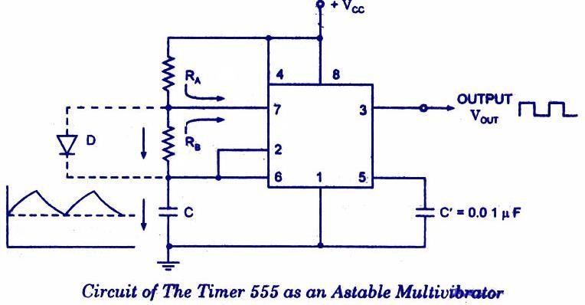

# Explain the current limiting features of 723 regulator.

Current limiting refers to the ability of a regulator to prevent the load current from increasing above a preset value. The characteristic curve of a current limited power supply is shown below. The output voltage remains constant for load current below Ilimit. As current approaches this limit, the output voltage drops. The current limit Ilimit is set by connecting an external resistor Rsc between the terminals CL and CS terminals shown below. The CL terminal is also connected to the output terminal Vo and CS terminal to the load.

# How are opto couplers superior to electrical coupling?

A circuit connected to the input of an optocoupler can be electrically fully isolated from the output circuit. Therefore, a potential difference of 100s or 1000s of volts can safely exists between two circuits without adversely influencing the optocoupler action.

# What is a switched capacitor filter?

Switched capacitor filter employs analog sample data techniques. The accuracy of the signal processing function depends on the accuracy of the capacitor ratios. The switched capacitor filters are all IC circuits. They were developed through the simulation of resistors by operating MOS capacitors with MOS switches.

# Draw the block diagram of a voltage to frequency converter.

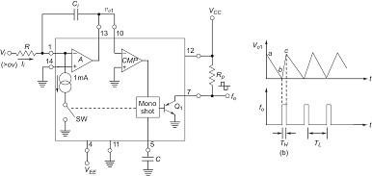

# PART B

**First part**

# OSCILLATORS

1. Explain the circuit of a RC Phase Shift Oscillator. **(7) (Nov/Dec 2021)**

# MULTIVIBRATORS

1. What are the modes of operation of a timer? Draw the functional diagram of a square wave generator using timer and derive its duty cycle. **(13) (Nov/Dec 2020, April/May 2021)**
2. A 555 timer is configured in Astable mode with RA = 2kΩ, RB = 6kΩ and C = 0.1µF. Determine the frequency of oscillation. **(ID) (4) (May 2016)**
3. Explain the working of astable and monostable multi vibrator using IC555 timer. Describe monostable multivibrator with necessary diagrams using IC 555 and derive for the expression for frequency of oscillation with relevant to the waveforms. (ID) (12) **(Nov 2013, Nov 2014, Nov 2015, Nov 2017)**
4. Describe astable multivibrator with necessary diagrams using op-amp and derive for the equation for period of oscillation and also draw its waveform. **(Nov 2018)**
5. Explain the operation of astable multivibrator using IC 555.**D (N/D-2014) (7)** (D)
6. Explain the operation of a monostable multivibrator using IC 555 timer. **D (N/Dec-13, A/M-2015) (May/Jun**-**11,Apr/May-10) (7) (D)**
7. Describe Monostable multivibrator with necessary diagrams and derive for ON time and recovery time. (10) **(May 2015,Nov 2018) (D)**
8. Design a square wave generator using 555 timer for a frequency of 120 Hz and 60% duty cycle. Assume C = 0.2 μF. (7) For a 4 -bit R -2R ladder D/A converter assume that the full scale voltage is 12 V. Calculate the step change in output voltage on input varying from 1001 to 1111. **ID (8) Nov/Dec 2017**
9. Design a wave generator using 555 timer for a frequency of 110Hz and 80% duty cycle. Assume C= 0.16µF (ID) (7) **(Nov 2018)**
10. With neat diagram, explain the operation of an astable and monostable multivibrators. . **D (N/D-17) MONOLITHIC SWITCHING REGULATOR**
11. Describe in detail about monolithic switching regulator. **(N/D-2014)(A/M-2015)(7) ICL8038 FUNCTION GENERATOR**
12. Draw the circuit diagram for IC 8038 function generator and explain pin configuration. **D (Nov/D-11)** (7)

# SAW-TOOTH WAVE GENERATOR & TRIANGULAR WAVE GENERATORS

1. Draw the schematic of a linear IC saw tooth waveform generator and explain the circuit operation. (**May/June – 16) (6**)
2. Explain about saw tooth wave generator with neat sketch. (7) (ID) **(May 2018,Nov 2018)**
3. Explain about the saw tooth waveform generator and explain the neat sketch. **D (13) (A/M-2018)**
4. Explain the working principle of Triangular wave generator circuit using op-amp and mention its application **(May 2019, Nov 2018) (13) (D)**

# IC 723 GENERAL PURPOSE REGULATORS

1. Describe the working of IC723 voltage regulator and explain the importance of current limiting techniques. Also, state the need for isolation amplifier. **(D) (7) (Nov’13, May 2014, May 2016)**
2. Draw the functional diagram of 723 regulator. And explain how it can be used as a high voltage regulator. . **(13) (Nov/Dec 2020, April/May 2021)**

# Second part

**FREQUENCY TO VOLTAGE AND VOLTAGE TO FREQUENCY CONVERTERS**

1. Write short notes on voltage to frequency converter. **D (A/M-2015) (6**)
2. Design a frequency to voltage converter using IC VFC 32 for a full scale output of 8 V for a full scale input frequency of 80 kHz with a maximum ripple of 8 mV. **D 7 (N/D-2017)**

# IC VOLTAGE REGULATORS

1. With a neat circuit diagram, explain the working of linear voltage regulator using operational amplifier. **D (Nov/Dec-15) (6)**
2. Draw the functional diagram and connection diagram of a low voltage regulator and explain. **(5) (ID)** **(Nov 2017)**
3. How is voltage regulator classified? Explain a series voltage regulator? **D (A/M-2010) (6)**
4. Summaries the working principle of IC723 general purpose voltage regulator. A 555 timer is configured in astable mode with RA = 2 k ohm RB = 6 k ohm and C = 0.1 μF. Determine the frequency of oscillation. **ID (12) + (4) May/June 2016**
5. Describe the performance parameters of IC regulators. **(6) (Nov/Dec 2021)**
6. Draw the functional diagram and connection diagram of a low voltage regulator and explain **D (7) (Nov/Dec-17)**

**SWITCHED CAPACITOR FILTER IC MF10**

1. Explain Switched Capacitor Filters. **(7) (Nov/Dec 2021)**
2. Explain how resistors can be realized using switched capacitor filter **(8) (Nov 2020, Apr/May 2021)**
3. With neat diagram explain the working of step down switching regulator and step up regulator. **D (N/D- 2012) (7)**
4. Discuss the functionalities and working of switched mode power supply**. D (6) Nov 2016)**

**ADJUSTABLE VOLTAGE REGULATORS**

1. State the significant difference between fixed and adjustable voltage regulators (D) (3) **(Nov 2018)**
2. Draw and explain the functional block diagram of the LM 317 three terminal adjustable regulators

# D. (Apr/May-13) (6)

**AUDIO POWER AMPLIFIER**

1. Give the classification of Power amplifiers and explain. **(6) (Nov/Dec 2021)**
2. Explain the following ICs function and application: (i) Audio Power Amplifier **(6)** (ii) Video Power Amplifier **(7) (D) (May 2019)**
3. Explain about a)Pulse width modulator b) Pulse Stretcher c)LM 380 Audio Amplifier **D (M/J-16) (6)**
4. Briefly write the working principle and functionalities of LM 380 audio amplifier. **D (8) M/J 2016**
5. Explain the working and functionalities of LM 380 power audio amplifier, Switched Capacitor Filter, Opto coupler (8) (D) **(Nov 2012, May 2016, May 2017, Nov 2017)**
6. Draw the block diagram of a typical IC audio power amplifier and briefly explain their salient features. **D (6)(Nov/Dec-17**)

# ISOLATION AMPLIFIER, OPTO-COUPLERS AND FIBRE OPTIC IC.

1. With Necessary Sketches, explain about Opto Couplers / Opto Isolators. **D (May-12) (7)**
2. Draw the block diagram and explain the working of charge balancing VFC. **ID (May-14)(6)**
3. Write short notes on Isolation amplifier. D **(Nov/Dec-16) (6)**
4. Discuss briefly about the Opto Couplers. **D (13) (A/M-2018)**